Assignment 5
Name :- Raghav Anil Bhise
PRN :- 22311792
Roll no. :- 391061
Title :- Use WordNet to identify semantic relationships such as synonymy, antonymy, and hypernymy in text data

1. Aim
To use WordNet from the NLTK library to identify semantic relationships such as synonyms, antonyms, and hypernyms in given text data.

2. Objective
- To understand the concept of lexical databases.
- To explore semantic relationships between words.
- To implement WordNet using Python and NLTK.

3. Theory
WordNet is a large lexical database of the English language. In WordNet, words are grouped into sets of cognitive synonyms called synsets, each expressing a distinct concept.
WordNet also stores relationships among words which makes it very useful in Natural Language Processing (NLP) applications such as:
- Text analysis
- Information retrieval
- Chatbots
- Machine translation

Semantic Relationships
1. Synonymy
Words having similar meaning.
Example: happy → joyful
2. Antonymy
Words having opposite meaning.
Example: good → bad
3. Hypernymy
A general category name for a word.
Example: dog → animal

4. Software Requirements
- Python 3.x
- NLTK Library
- Google Colab / Jupyter Notebook / VS Code

5. Procedure
- Install the NLTK library.
- Import WordNet corpus from NLTK.
- Download WordNet datasets.
- Accept a sentence from the user.
- Tokenize the sentence into words.
- Retrieve WordNet synsets for each word.
- Extract synonyms, antonyms and hypernyms.
- Display the semantic relationships.

6. Program & Output
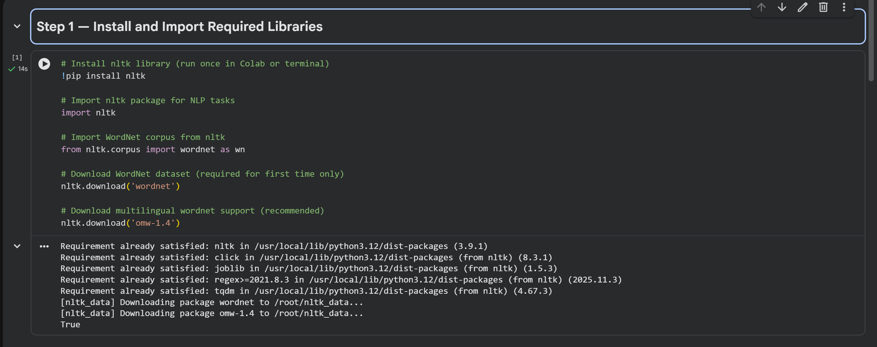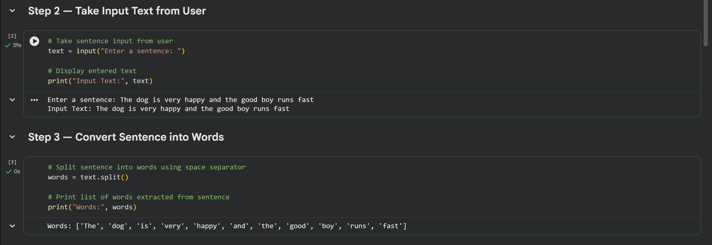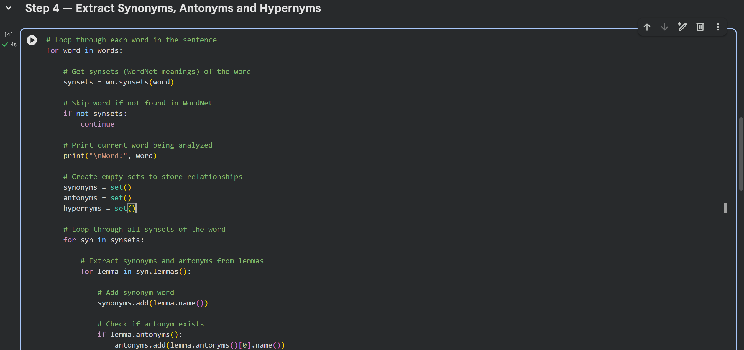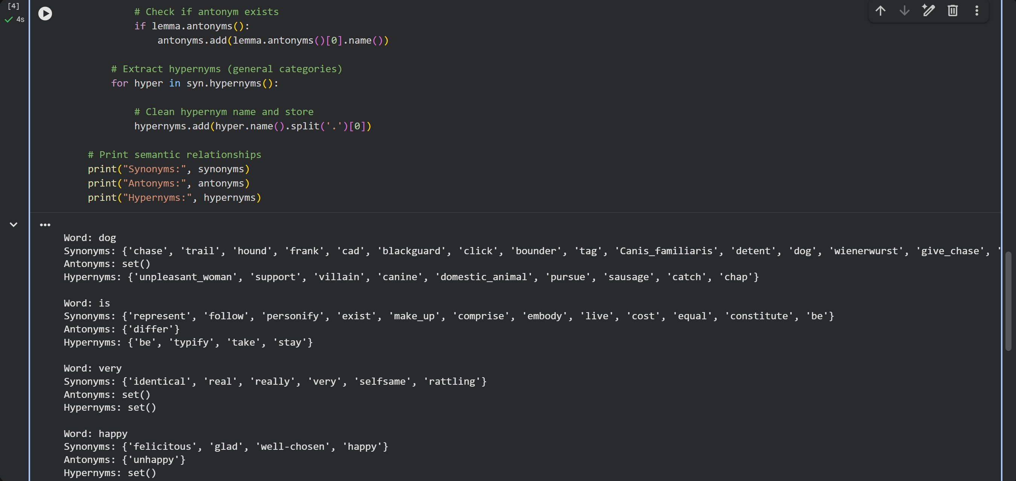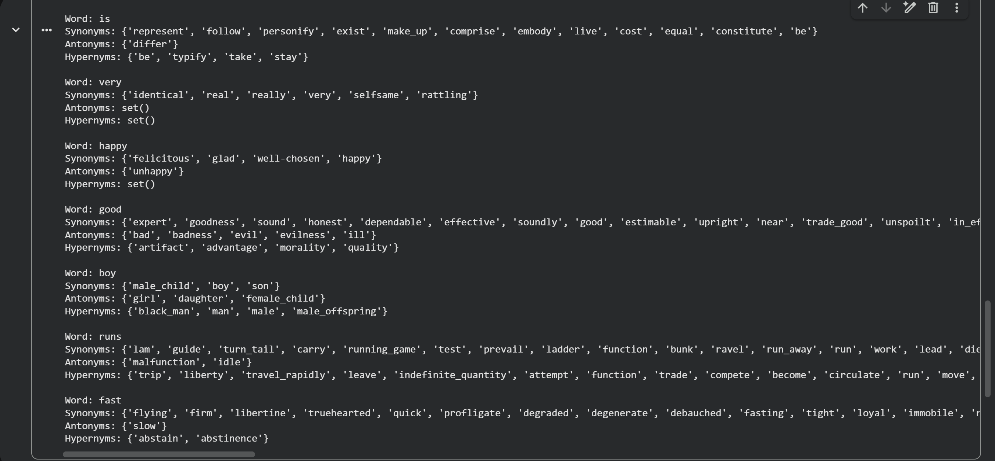

7. Result
The program successfully extracted synonyms, antonyms, and hypernyms from the input sentence using the WordNet lexical database.

8. Conclusion
Thus, WordNet can be effectively used in Natural Language Processing to analyze semantic relationships between words and improve language understanding in AI systems.

